USRP ID UPDATE

# **Issue:**

SUMMARY: Updating profile in ASOC  
DETAILED_DESCRIPTION: While validating Address in USRP screens getting message "Please update your profile in ASOC".

# **Sample Ticket:**

**Ticket #: 000000225067083**

**Resolution Steps:**

1. Check user’s email id and password in user_prof table in AVS DB.

SELECT EMAIL_ADDR,PSWRD FROM USER_PROF WHERE HR_ID = ‘az528d’;

1. Open AVW homepage
2. Enter email address and password, after that click on edit personal profile.

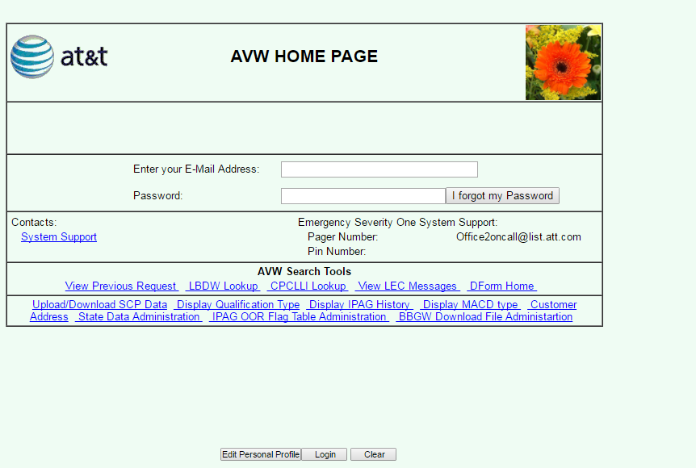

1. Enter USRP_ID in USRP ID Field.

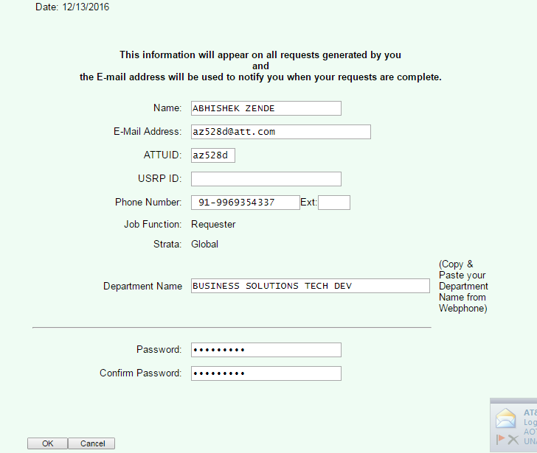

1. Click Ok and we are done.